AIM: To Execute Basic networking commands in Linux.
TOOLS/SOFTWARES REQUIRED: Linux OS
THEORY:

Kali Linux
Definition:
Kali Linux is a Debian-based Linux operating system developed for network security, penetration testing, and network analysis. It includes a large collection of tools related to networking and system security.
Why:
It is used to study, test, and analyze networks and security vulnerabilities in a controlled environment.
Where:
Used in networking labs, cybersecurity labs, and by students and professionals learning network security.
How:
Kali Linux provides pre-installed networking and security tools that allow users to monitor, test, and analyze network behavior.
Linux Commands:
- ifconfig
- Definition:
ifconfig (interface configuration) is a command used to view and configure network interfaces on a Linux system.
- Why:
It is used to check network interface details such as IP address, MAC address, and connection status.
- Where:
Used on Linux-based operating systems for network configuration and troubleshooting.
- How:
The command displays information about all available network interfaces and allows enabling or disabling them.

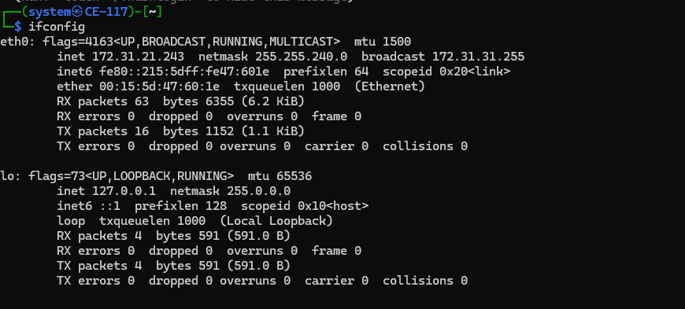

- ping
- Definition:
ping is a network utility used to test connectivity between two devices on a network.
- Why:
It helps verify whether a destination system is reachable and checks network latency.
- Where:
Used in local networks and on the internet for network troubleshooting.
- How:
It sends ICMP echo request packets to the destination and receives echo replies.
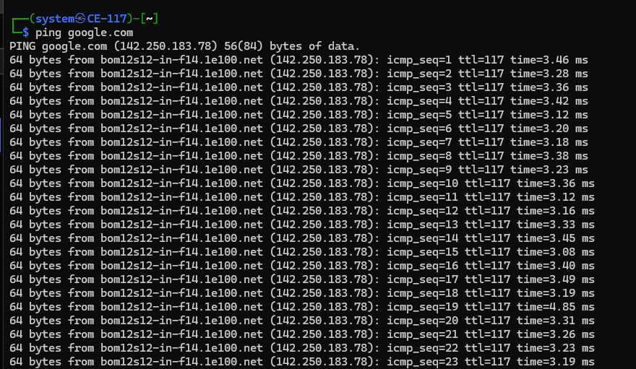
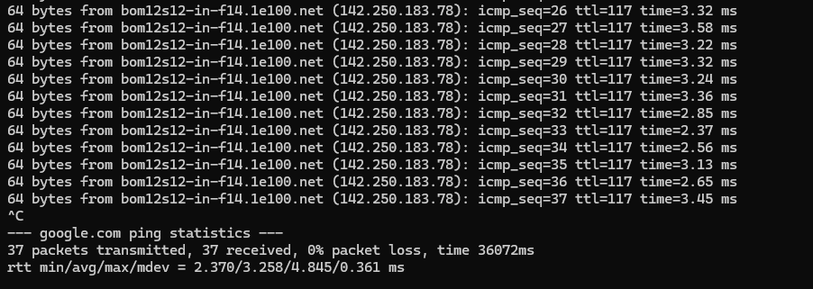

- traceroute
- Definition:
traceroute is a command used to trace the path of packets from the source to the destination.
- Why:
It helps identify network delays or failures along the transmission path.
- Where:
Used in network diagnostics and routing analysis.
- How:
It sends packets with increasing time-to-live (TTL) values and records each router hop.
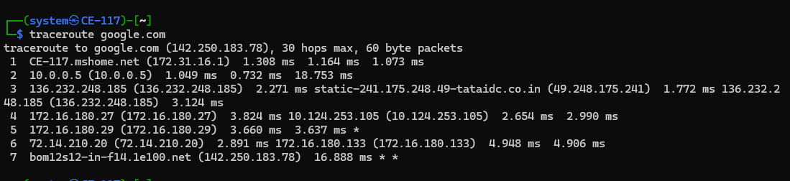

- netstat
- Definition:
netstat (network statistics) is a command that provides information about network connections, ports, and routing tables.
- Why:
It is used to monitor active network connections and detect unwanted or suspicious activity.
- Where:
Used on computers and servers for network monitoring and administration.
- How:
The command displays details of active connections, listening ports, and routing information.
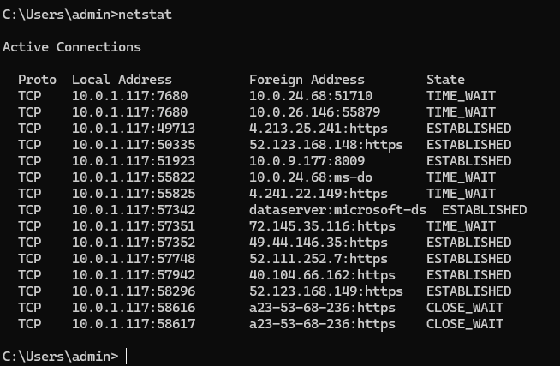

- nslookup
- Definition:
nslookup (Name Server Lookup) is a command used to query DNS servers for domain name information.
- Why:
It helps in checking whether domain names are resolving correctly to IP addresses.
- Where:
Used in DNS troubleshooting and network administration.
- How:
The command queries a DNS server and returns the corresponding IP address or DNS record.
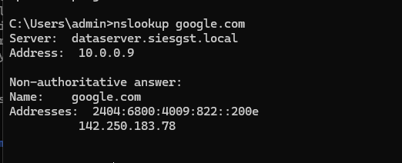
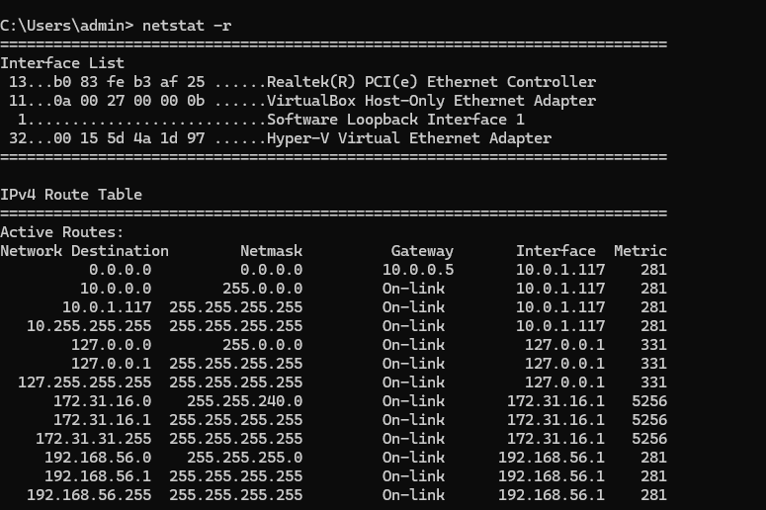

CONCLUSION:
Networking tools such as Kali Linux, ifconfig, ping, traceroute, netstat, and nslookup play an important role in understanding and analyzing computer networks. These tools help in observing network configuration, checking connectivity, identifying packet paths, monitoring active connections, and resolving domain names. Studying these tools provides a clear understanding of how data flows across a network and helps build a strong foundation in computer networking concepts.

